ASSIGNMENT V

Microsoft Azure Administrator | Jan-2026

Neme Aduh

Configure Azure Virtual Desktop to connect to a Remote Desktop
- Create a Resource Group ‘Neme-RG’
- Create a Virtual Network ‘Neme-Vnet’
- Create a Host Pool and VM then deploy

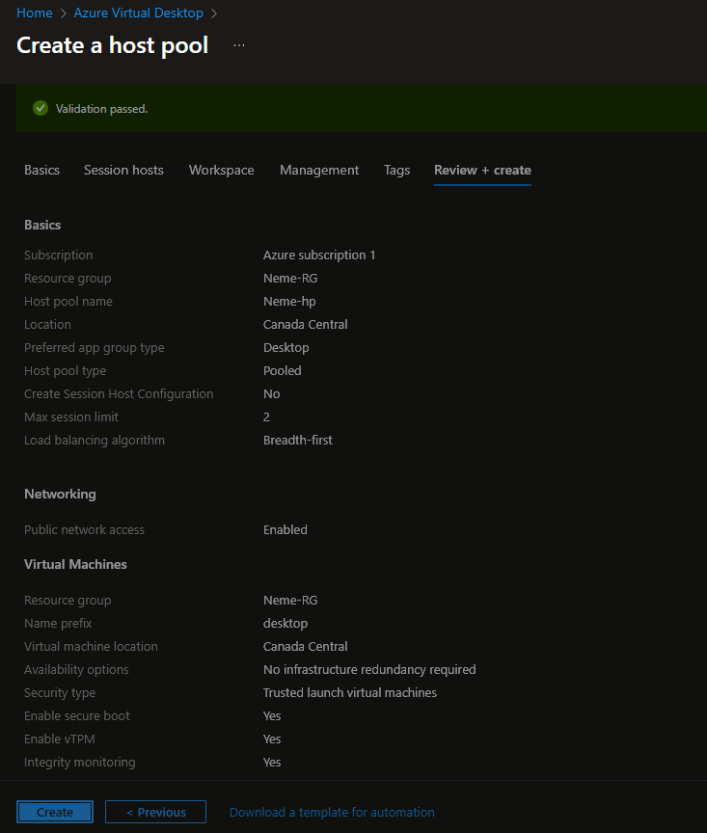
- After deployment is complete- goto hostpool resource click on Settings>RDP Properties>connection information
- Then configure ‘Microsoft Entra single sign-on’ and save

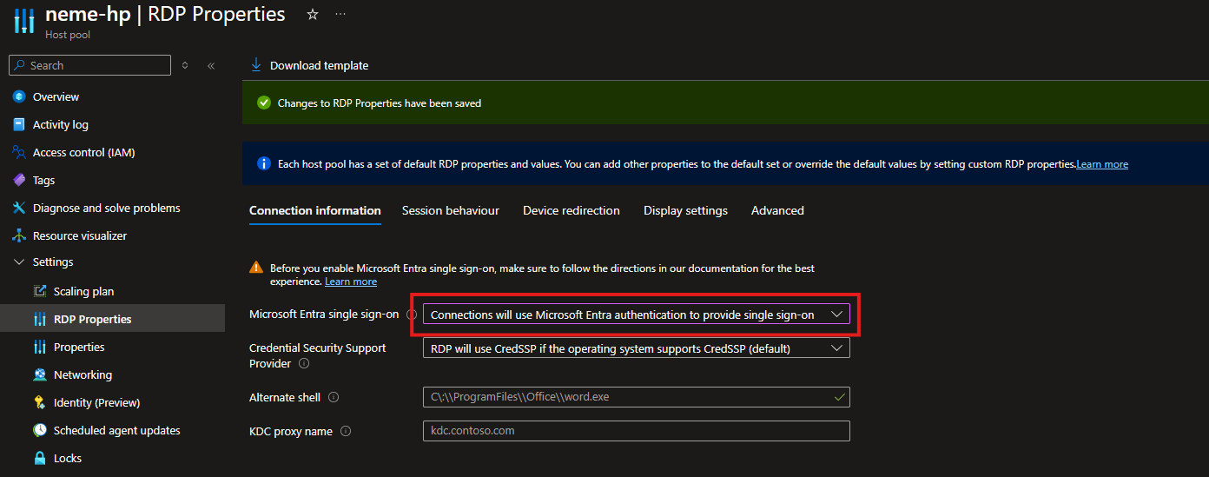
- Hostpool and ApplicationGroup have been created, now we need to create the Workspace then register the ApplicationGroup
- Search for Azure Virtual Desktop> Workspace>Create workspace, then click ‘+Register application groups’ and add accordingly, Review + Create.

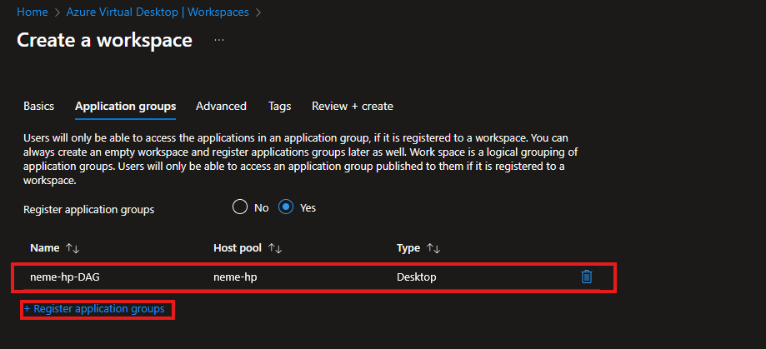

- Next Step: Setting the permissions for users, groups- Within the Entra ID, create a new user ‘Suaila Benjamin’ and assign global administrator role
- At the level of Resource Group, add two role assignments to user ‘Suaila Benjamin’ [‘Virtual Machine User Login & Virtual Machine Administrator Login’]
- Then, goto AzureVirtualDesktop>ApplicationGroup and add user ‘Suaila Benjamin’ to the application

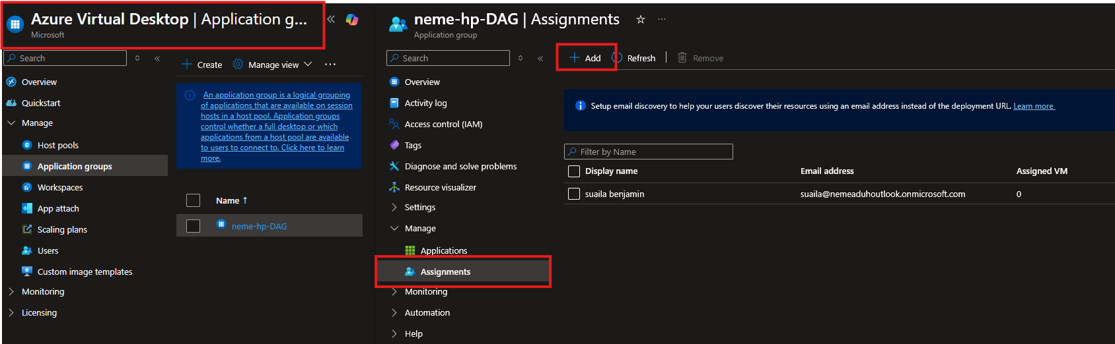

- Next Step: Connect the AVD using the application – Download AzureVirualDesktop client for windows

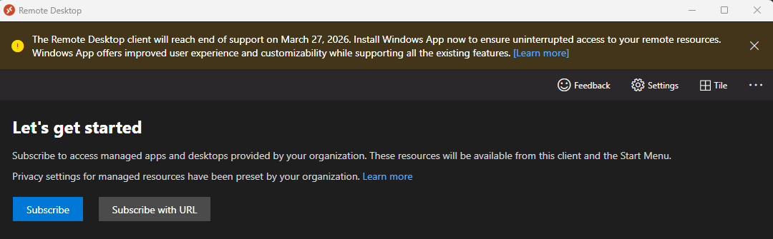
- Next Step: Connect the AVD using the application – Download AzureVirualDesktop client for windows
- Within the Entra ID - Copy the principal name of the user ‘suaila@nemeaduhoutlook.onmicrosoft.com’ and sign in with the Remote Desktop

Validation check:
- Below image displays Remote Desktop successfully connected with office365 packages

